QUESTION: Based on your content knowledge and the images below, explain how the social and economic characteristics of Ancient Nubia were similar and different from those of Ancient Egypt.

  - Where was Kush located and what was its overall relationship to Egypt?
  - How were Kush and Egypt alike in their social and economic characteristics?
  - How were Kush and Egypt different in their social and economic characteristics?

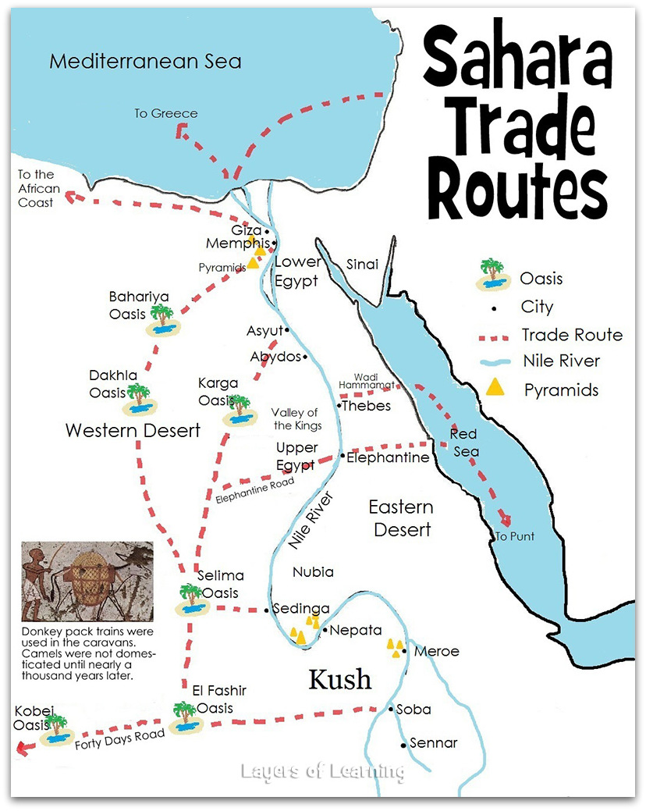

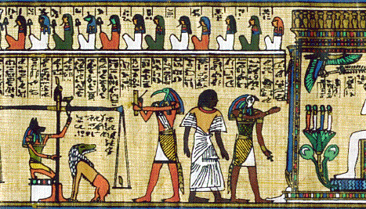
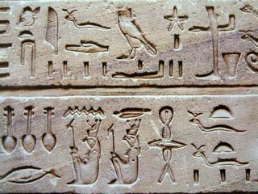

KUSHITE WRITING KUSHITE PAINTING

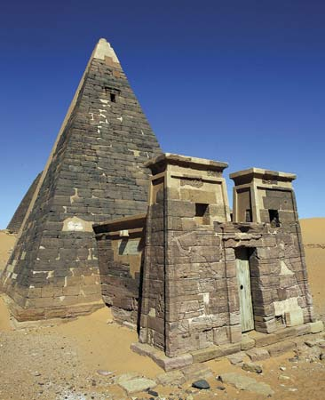
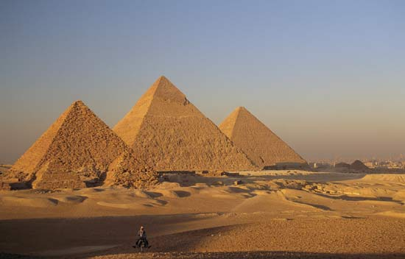

EGYPTIAN BURIAL TOMB

KUSHITE BURIAL TOMB

